|  |  |
| --- | --- |
|  | *Shahid Smarak College* |

*Kathmandu, kirtipur – 10*

Submitted by: -

Amir Maharjan

BCA 3rd Semester

Submitted to: -

Department of BCA.

Introduction

When making the website, I used HTML (Hyper Text Markup Language) and CSS (Cascading Style Sheet. All the codes have been written with the help of Virtual Studio code (VS Code). The most basic or necessary to learn things in HTML is how to create a table and form. These are essential when learning HTML.

The codes are divided into 11 divisions or sections. The first division contains the motto Shahid Smarak College stands by “Community for You, You for Community.” Its contacts details are also mentioned along with its social media platforms.

Reference

I have taken reference from the following websites :

* Shahid Smarak College Official Website([www.sscollegekirtipur.edu.np](http://www.sscollegekirtipur.edu.np))
* Janamaitri Multiple Campus Official Website([www.janamaitri.edu.np](http://www.janamaitri.edu.np))
* Some articles from the internet as well.

Table of Content

1. Home
2. Division 1

ii. Division 2

iii. Division 3

iv. Division footer

1. About Us
2. Courses
3. Notices
4. Downloads
5. Students Page
6. Links
7. Contacts
8. Gallery

Home

The home page is divided into 5 divisions / sections and is named index.html. Division 1, 2 and 3 are displayed in every other html file like about Us, contacts, etc.

* Division 1

In this division, the motto of Shahid Smarak college is mentioned “Community for You, You for Community.” along with its contact details and its social media platforms.



The tags used in this Division are:

|  |  |
| --- | --- |
| TAGS | Descriptions |
| <Div> | The <div> tag defines a division or a section in an HTML document. |
| <Text> | The Text Tag Group is a group of tags that are used to create well-formatted text documents. |
| <A> | Creates a hyperlink, a URL can address (anywhere). |
| <Img> | Used to embed an image in the HTML file. |

The positions, font-size, image height and width are adjusted using the CSS.

* Division 2

Division 2 of the home page shows college logo, Name and its affiliation with Tribhuvan University (T.U).



The Tags that are used in this division are:

|  |  |
| --- | --- |
| TAGS | Descriptions |
| <H1> | A heading tag that is most commonly used for web page title. |
| <P> | Defines a paragraph |
| <br> | Insert a single line break. |

The repeated tags are: <div> and <img>.

*Note: Repeated tags will not be described again.*

* Division 3

This division contains the most important part of the website, the navigation bar. The navigation bar helps in jumping from one page to another.



|  |  |
| --- | --- |
| TAGS | Descriptions |
| <ol> | Defined an ordered format. |
| <b> | Makes the texts bold. |
| <li> | Defines a list item. |

The repeated tags are <div> and <a>.

* Division Footer

This division contains contact details, location of Shahid Smarak college using Google maps and a few quick links.

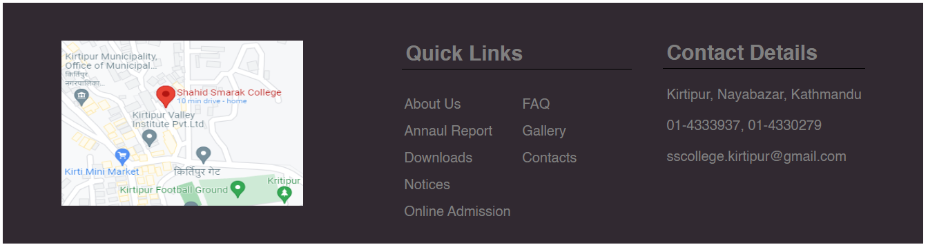The tags that are used in this section are all already mentioned. The repeated tags are: <div>, <a>, <p>,<b>,<table>,<thead>,<tr>,<td><tbody>,<h2>.

About Us

The “About Us” page is named “About US.html” and it contains brief information about Shahid Smarak College, its objectives and its missions.

* Division Four

Division four contains the contents of about us. First a <div> tag is used to create a row, then inside that <div> another 2 <div> tags are used to create 2 columns inside that row.

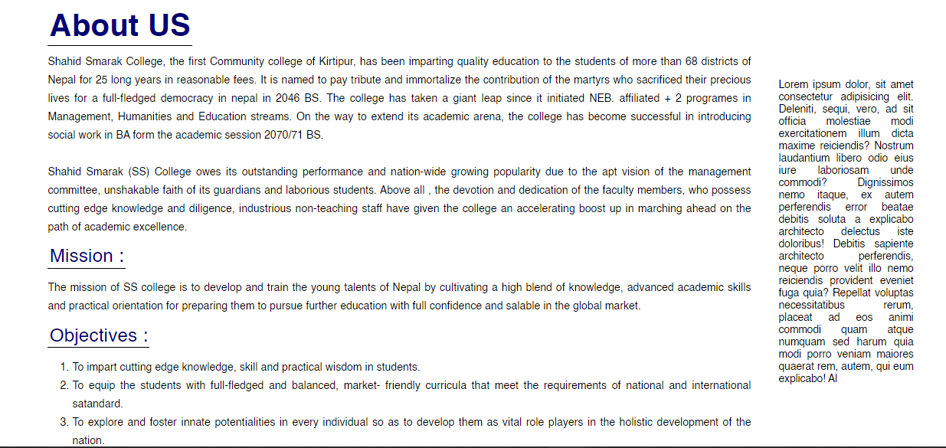

The tags that are used in this division are:

|  |  |
| --- | --- |
| TAGS | Descriptions |
| <h3> | Similar to H1 except the font-size is smaller. |
| <button> | Used to define a clickable button. |

The repeated tags are <div>,<h1>, <p>,<br>,<ol>, <li>, <text>and <b>.

Courses

The Courses sections displays all the courses that are taught in Shahid Smarak College.

* Division 5

In order to make division 5, 2 rows were created using the <div> tag. In the first row, 3 columns were added while in the second row only two columns were added.

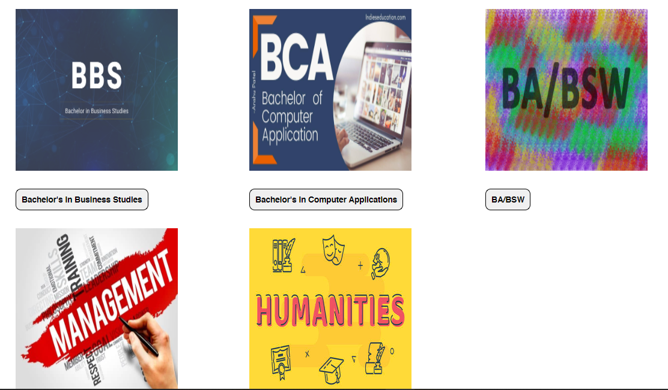

The tags that were used in division five are:

|  |  |
| --- | --- |
| TAGS | Descriptions |
| <table> | Defines a html table. |
| <tr> | Inserts a table row. |
| <td> | Defines a standard data cell in the html table. |

The repeated tags are: <div>, <h1>, <button>, <b>.

Notices

In this section of the web page, the notices that are published by the college are posted here.

* Division Six

All the notices/images are inserted with the help of photo Gallery.

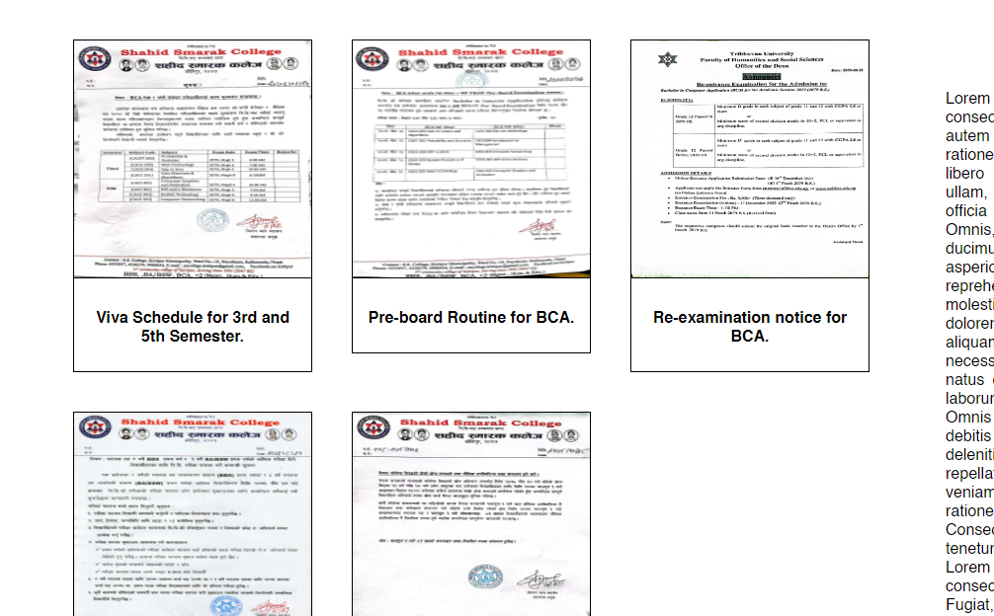

All the tags that are used in Division six are already listed above.

The repeated tags are: <h1>, <div>, <a>, <img>,<p>, <b>.

Students Page

Some articles about important topics are being displayed.

* Division Eight

The <div> tag is used to create a single row and inside those 2 columns are added. Inside the first column <p> tag is used to brief us about the article and to see the full article. We have to press the “SEE MORE” button created using the <button> tag.

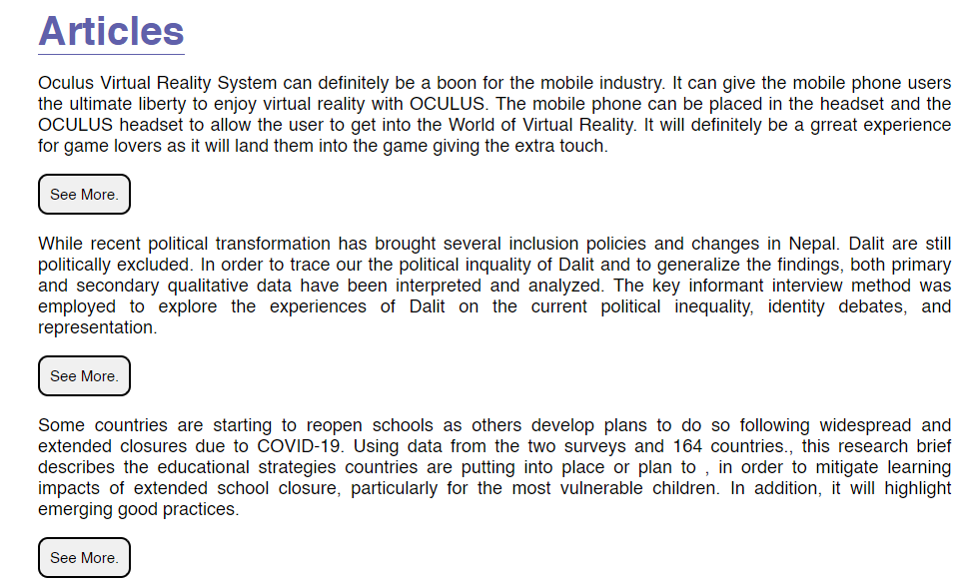

The tags that used in this division are already used. The repeated tags are: <div>, <text>,<b>,<p>,<button>.

Contact US

The contact details about the college is mentioned and a small form is also created for taking feedback of parents and students.

* Division Ten

One row is created using <div> and inside that row 2 column is created where in 1st column contacts are displayed and in the 2nd column form is displayed.

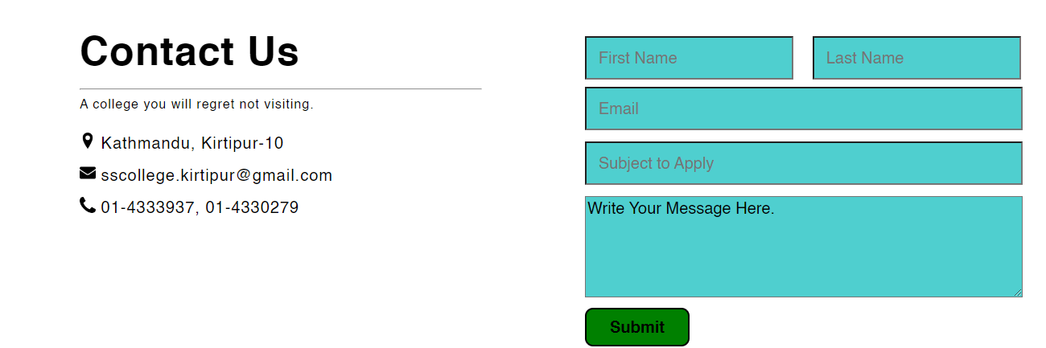

The tags that are used in division ten are:

|  |  |
| --- | --- |
| TAGS | Descriptions |
| <hr> | Defines a thematic break in html page. |
| <span> | An inline container used to mark up a part of a text. Similar to <text> tag. |
| <thead> | Used to group heading content. |
| <th> | Defines a header cell. |
| <tbody> | Used to group body content. |
| <tfoot> | Used to group foot content. |
| <form> | Used to create an interactive form in webpage. |

The repeated tags are: <div>, <text>,<h1>,<br>,<img>,<table>,<td>, <tr>

Gallery

Some pictures of Shahid Smarak College and its teachers who are celebrating Teej and Birthdays of colleague.

* Division Eleven

The pictures of college are grouped into one and a image gallery is created to showcase all the image. It is similar to Notices.

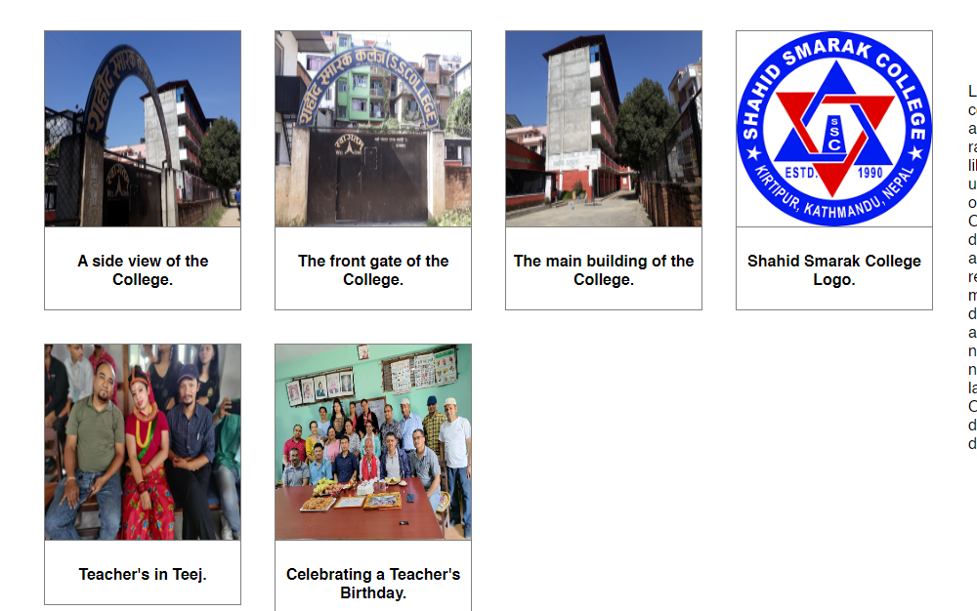

The tags used in division 11 are all already used. The repeated tags are:

<div>, <a>, <img>, <p>, <b>.

--------------The end-------------